I need to create a new dashboard that will mainly focus on PI products (Parallel Import) and provide the Purchase, Sales, Profit, Margin summary. This screen name would be ‘PI Purchase V/s Profit’.
Following are the details we need to display

PI Purchase V/S PI Profit
We have team who buying the PI products.
Now I have to create the Dashboard to track the PI purchase & PI sales.
Below are the more details
Show the purchase and profit table.
- Breakdown the purchase product in old and new category
- Following columns shall be display
- Buyer name (Top on the table)
- Month: This column will display the month names
- Old Products: This column have 3 more sub column that will display ‘Purchase, Profit, margin’.
- Purchase: This column display old PI product purchase amount
- Expected Profit: This column display PI products expected profit for each month
- Expected Margin: This column display PI products expected margin for each month
- New Product
- Purchase: This column display new PI product purchase amount
- Expected Profit: This column display new PI product expected profit.
- Expected Margin: This column display new PI product expected margin.
- Total Purchase: This column display total PI product purchase amount. (Old + New)
- Total Profit: This column display total PI product expected profit. (Old + New)
- Total Margin: This column display total PI product expected margin. (Old + New)
Note: Refer the below image
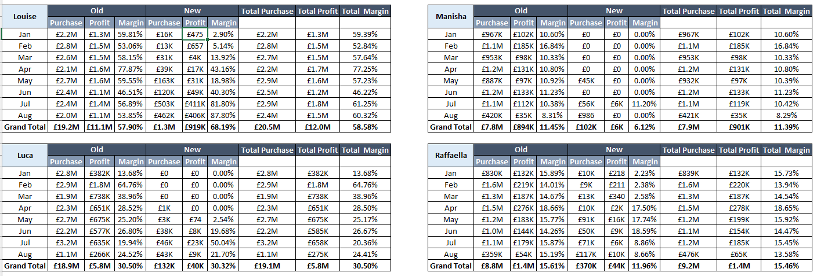

New License:
It will display new PI Products. This will be a dedicated table that will display the new product list. Following are the column shall be display in the new product list table.
- Country
- Buyer
- Lax part no
- Description
- Granted Date
- Buying Comments
- Remark
Based on the table data, show the below summary/cards
Status Till Jul'26
Remarks | No of Products
MAH Objection | 0
Price Issue | 3
Variation | 3
Not On Order | 4
Awaiting MAH | 7
In Labelling / On Order | 26
Stock Received | 32
Grand Total | 75

Buyers Details:
- This screen will display purchase product country, buyer name, Purchase amount, Expected profit & Expected margin for the entire year. Design the table based on the attached screenshot.
- For the country and Buyer name use the filter option in the table.
- Based on the attached table, you have to redesign the table structure and target to show the Purchase, Profit, margin data in the minimum space, so that, client easily monitor it.
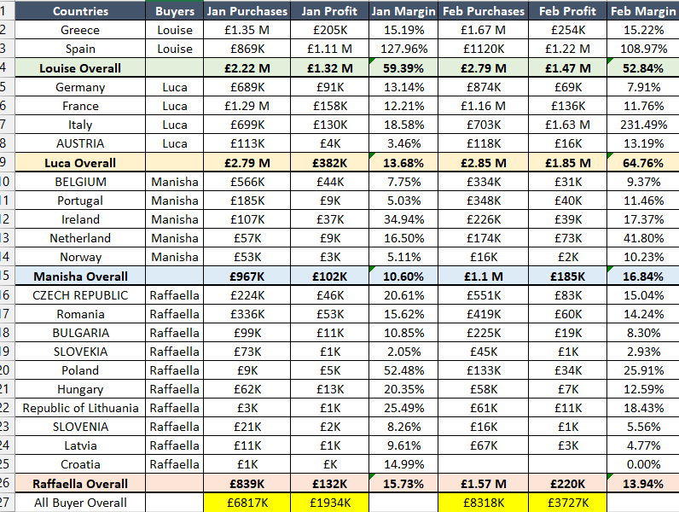

PI Product Sales:
It will display the entire year PI product sales. The table will display the below column
- Old Products
- Sales
- Profit
- Margin %
- New Products
- Sales
- Profit
- Margin%
- Overall PI
- Sales
- Profit
- Margin%

15% PCA:
PCA stands for ‘Prescription Cost Analysis’. It will help to identify product sell volume in the UK market. Now we need to identify product total volume, how much volume BNS sold. We already have this data. You have to design the screen and display the data in the table format. Following columns shall be display.
- Catalog no
- Part description
- Category
- Current Stock
- Daily
- Daily PCA: It will display daily PCA value. Ex: 10
- Qty: It will display daily sold qty. Ex: 5
- Difference: It will display the difference. Difference = Daily PCA - Qty
- MTD
- 15% PCA: It will display the quantity.
- MTD Qty: It will display the MTD quantity
- Diff: It will display the difference.
- PCA Achievement
- MDT%: It will display the MTD%
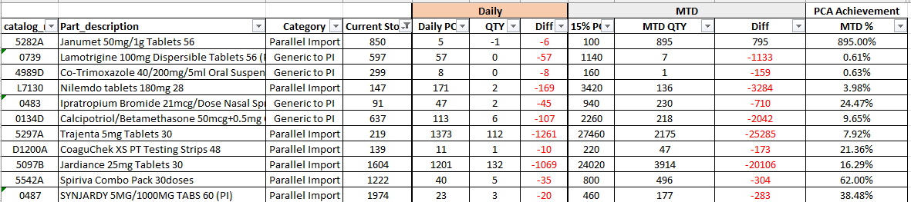

- Over Stock: It will display the overstock products.
- Code
- Description
- Stock
- True Cost
- Stock Value
- No of Days Stock

